**MOOREBANK HIGH SCHOOL**

**COMPREHENSIVE STUDENT PLACEMENTS 2024 ENROLMENT POLICY**

**1.**The *Moorebank High School Comprehensive Student Placements 2024 Enrolment Policy* outlines the processes and guidelines applicable for the placement of students in the comprehensive stream of Moorebank High School in 2024 and for Year 7 2025. It replaces Moorebank High School’s *Comprehensive Student Placements 2019 Enrolment Policy* and reflects changes arising from the Department of Education’s *General Enrolment Procedures*, implemented from 22 July 2019.

# 2024 Enrolment Cap and Buffers

An enrolment cap for a school is established centrally, based on available permanent accommodation. Within the enrolment cap, a number of enrolment places (the buffer) must be set aside for the enrolment of local students arriving throughout the year. **Places in the local enrolment buffer are not to be offered to non- local students.**

# Enrolment Criteria for Placement as a Comprehensive Student for 2024

## In Area Enrolment Application

When seeking enrolment at Moorebank High School the following original documents are required (see the checklist on page 15 of the *Application to enrol in a NSW Government school).*

* Proof of the student’s residential address in the name of parent or caregiver. These could include council rates notice, residential lease, electricity account. Families must live in the Department of Education’s designated intake area to be considered an in-area student (see appendix 1).
* A statutory declaration if the student lives with a legal guardian other than a parent.
* If the school is near or above the buffer mentioned above, parents or caregivers will be required to use the Department of Education’s 100-point residential address check to verify that the student being presented for enrolment lives within the intake area (see appendix 2).
* A birth certificate or passport to verify the name and age of the student enrolling.
* Australian Immunisation Register (AIR) Immunisation History Statement for all students enrolling in NSW Government schools for the first time.
* Copies of any family law or other relevant court orders.
* Copies of medical / health care or emergency action plans.
* Evidence of any disability or other support needs, including any learning and support plans.
* Passport or travel documents and current visa and previous visas (if applicable) if the student is a

permanent resident but not an Australian citizen. These documents plus an Authority to Enrol issued by the Temporary Residents Program Unit if the student is a temporary visa holder.

* Recent School Reports.

Once an application for enrolment has been received the following will occur.

* A student information request will be sent to the previous school for review before the enrolment and an interview with the Principal or Deputy Principal will be held.
* An enrolment interview will be held with the Principal or Deputy Principal to discuss the student’s learning needs and history, school expectations, programs and school organisation.
* Once a student has been accepted, all forms will need to be returned to the school and full school uniform purchased before enrolment can commence. In most situations, the starting date will be up to three to four days following the interview. However, this may be delayed following communication from the previous school, or because of information raised during the interview, that necessitates the development of health care or other plans to ensure a smooth transition into the school.

## Out Of Area Enrolment Application - Comprehensive Placements

Students residing outside of the local in-take area may be considered for enrolment if they are eligible to attend and the school can accommodate them. Applicants should follow the application process as set out in 3a above.

As per Department of Education policy, schools cannot offer places to non-local students if the local area buffers have been reached.

Where demand for non-local enrolment exceeds the number of available places below the enrolment buffer, an enrolment panel (consisting of one executive staff member, one teaching staff member and one school community member nominated by the school’s parent organisation) will consider and make decisions on all non-local enrolment applications using the following criteria.

* + 1. Sibling preferences, if the student applying for enrolment has a sibling enrolled within the comprehensive and/or selective streams of the school.
    2. If the student was enrolled at an in-area partner primary school (Nuwarra, Newbridge Heights and Chipping Norton primary schools) in Year 6.
    3. Compassionate circumstances.
    4. Specific welfare circumstances of the student.
    5. Proximity of the student’s residence to the school.
    6. Availability of subjects or combination of subjects The above list is in priority order.

Applicants are advised to include evidence that supports the assessment of the application against the criteria. Applications for out-of-area enrolment can include previous reports, current comments from the applicant’s Principal and any other documents that constitute ***evidence*** for the above criteria.

# 4. Specific Enrolment Criteria for Comprehensive Students Commencing Year 7 2025

## 2025 Year 7 Comprehensive Students’ Enrolment Ceiling and Buffer

An enrolment cap for a school is established centrally, based on available permanent accommodation. Within the enrolment cap, a number of enrolment places (the buffer) must be set aside for the enrolment of local students arriving throughout the year. **Places in the local enrolment buffer are not to be offered to non- local students.**

The school will use the anticipated enrolment numbers in Years 8 - 12 for 2024, and anticipated in-area enrolments for Year 7 2025, to determine if the enrolment buffer and / or cap have been reached, before

making any offers to non-local students.

## In-Area Enrolment – Comprehensive Placements

* + Parents and carers requesting placement in Year 7 at a NSW Government school in 2025 need to complete an expression of interest form.
  + For students currently enrolled in NSW Government primary schools, please return this form to your child’s primary school.
  + For students not currently enrolled in a NSW Government primary school, please return this form to the NSW government secondary school that you intend to enrol your child in.
  + Both **paper and digital** expressions of interest must be returned on or before 24 March 2024.
  + Once your child has been offered a place in our school you will receive an email requesting that you **complete an Online Application to Enrol in a NSW Government School**. 3. Please complete all details on the Online Enrolment Application as soon as possible.
  + Proof of the student’s residential address in the name of parent or caregiver. These could include council rates notice, residential lease, electricity account. Families must live in the Department of Education’s designated intake area to be considered an in-area student (see appendix 1). As Moorebank High School is above its buffer in terms of student numbers, all students wishing to enrol will be required to provide 100 point proof of address.
  + A statutory declaration if the student lives with a legal guardian other than a parent.
  + The Online Enrolment System outlines all the other documentation that must be provided , **before an enrolment will be considered**.
  + This documentation includes,
    - Originals of a birth certificate or other identity document.
    - Originals of an Australian Immunisation Register (AIR) Immunisation History Statement for all students enrolling in NSW Government schools for the first time.
    - Copies of any family law or other relevant court documents.
    - Copies of medical / healthcare or emergency action plans.
    - Evidence of any disability or other support needs, including any learning and support plans.
    - For Non-Australian citizens, passport or travel documents and current and previous visas if applicable.
    - For temporary visa holders, passport or travel documents, current and previous visas if applicable, plus an Authority to Enrol issued by the Temporary Residents Program Unit or International Student Centre.
  + The final decision on enrolment will be made following consideration and acceptance of your application to enrol by the school principal. You may be contacted for more information in order to ensure a smooth transition into high school. Depending on plans that need to be put into place, in rare circumstances, this may delay the start date of the student in 2024.
  + You will then receive a letter confirming whether or not your child has been accepted for enrolment.

**No student will be able to attend until all required documentation has been received including the 100 points proof of address.**

## Enrolment Placement Panel

This panel has been established to ensure that fair and equitable decisions are made about the enrolment of comprehensive students in Year 7 at Moorebank High School. The placement panel will primarily consider out-of-area applications for enrolment.

The panel consists of,

* + One executive staff member
  + One teaching staff member
  + One school community member nominated by the school’s parent organisation

The Enrolment Placement Panel is responsible for,

* + Monitoring, evaluating and revising this policy from year to year or as required.
  + Consideration of out-of-area comprehensive applications in Year 7 following the enrolment criteria listed below.
  + Placement of out-of-area Year 7 comprehensive applicants on an ***order of eligibility and merit***

list comprising of

* + - Those students to whom offers shall be made, **pending submission of required paperwork.**
    - Those students who shall be placed on a waiting list in order of merit.
    - Those students who are unsuccessful in their application.

## Out Of Area Enrolment Application - Comprehensive Placements

* + Parents and carers requesting placement in Year 7 at a NSW Government school in 2025 need to complete an Expression of Interest form. This form can be completed online in a mobile friendly experience via a link on the primary school’s enrolment page.
  + For students not currently enrolled in a NSW Government primary school, please complete the online expression of interest form for the NSW government secondary school that you intend to enrol your child in.
  + All expressions of interest must be returned on or before 24 March 2024.

The school’s Enrolment Placement Panel will meet to consider expressions of interest from prospective Year 7 students residing outside the local in-take area that are lodged in 2024. Applicants are advised to **include evidence** that supports the panel’s assessment of the application against the criteria. The panel will take into account:

1. Sibling preferences, if the student applying for enrolment has a sibling enrolled within the comprehensive and/or selective streams of the school.
2. If the student was enrolled at an in-area partner primary school (Nuwarra, Newbridge Heights and Chipping Norton primary schools) for more than 12 months and is in Year 6.
3. Compassionate circumstances.
4. Specific welfare circumstances of the student.
5. Primary principal endorsement.
6. Proximity of the student’s residence to the school

The above list is in priority order.

The panel will consider documented evidence provided for the criteria alone. **Applications will be ranked based on the priority order of the criteria met; the number of criteria met; the extent to which each criteria has been met.** For example, a student who has attended one of the in-area partner primary schools and who has two siblings at the high school already, may be ranked more highly than a student who is applying on the grounds of close proximity to the in-take boundary and compassionate circumstances. Having one or more siblings in the selective or comprehensive stream alone may not guarantee a high ranking because the panel considers all criteria to make a decision for each application. ***Parents are advised to carefully consider this before applying to enrol the first of two or more children at the school.***

Applicants are advised to include evidence that supports the panel’s assessment of the application against the criteria. Applications for out-of-area enrolment can include previous reports, certificates, current comments from the applicant’s Principal and any other documents that constitute ***evidence*** of the criteria above.

The order of eligibility and merit list for out-of-area applicants will be maintained up to the end of Term 1 2025.

For students to whom offers shall be made you will be asked to complete an Application to Enrol in a NSW Government School. Please complete all details on this form and return it as soon as possible.

* + Proof of the student’s residential address in the name of parent or caregiver. These could include council rates notice, residential lease, electricity account. Families must live in the

Department of Education’s designated intake area to be considered an in-area student (see appendix 1).

* + A statutory declaration if the student lives with a legal guardian other than a parent.
  + The checklist on Page 15 of the Application to Enrol in a NSW Government School outlines all the other documentation that must be provided.
  + This documentation includes,
    - Originals of a birth certificate or other identity document.
    - Originals of an Australian Immunisation Register (AIR) Immunisation History Statement for all students enrolling in NSW Government schools for the first time.
    - Copies of any family law or other relevant court documents.
    - Copies of medical / healthcare or emergency action plans.
    - Evidence of any disability or other support needs, including any learning and support plans.
    - For Non-Australian citizens, passport or travel documents and current and previous visas if applicable.
    - For temporary visa holders, passport or travel documents, current and previous visas if applicable, plus an Authority to Enrol issued by the Temporary Residents Program Unit or International Student Centre.
  + You may be contacted for more information in order to ensure a smooth transition into high school. Depending on plans that need to be put into place, in rare circumstances, this may delay the start date of the student in 2025.

### Enrolment will only proceed upon the submission of required paperwork.

1. **Appeals**

Parents and carers who wish to appeal the decision of the Enrolment Placement Panel must do so in writing, addressed to the Principal. The Principal will review the decision of the enrolment panel against the criteria and procedures listed in this policy. No new evidence will be considered during the appeal process.

All appeals must be received by the Principal **within two weeks of the date of the notification letter** informing parents that they been unsuccessful in their application or that their child has been placed on a waiting list.

# Information Updates

It is a condition of enrolment that the applicant keeps the school updated in respect of changes to their residential address, medical information and emergency contact numbers.

# Enrolment Officers

Enrolment placement panel applications are managed by The Enrolment Officers. Any enquiries about enrolment may be directed to the enrolment office on (02) 9601 3999 or emailed to-

[moorebank-h.school@det.nsw.edu.au](mailto:moorebank-h.school@det.nsw.edu.au).

***The Principal and the President of Moorebank High School Community Focus Group have endorsed this policy***.

Mrs R Charara

Relieving Principal

30 May 2024

**Appendix 1: Map of Boundary for the Moorebank High School Designated Intake Area**

**=** Boundary

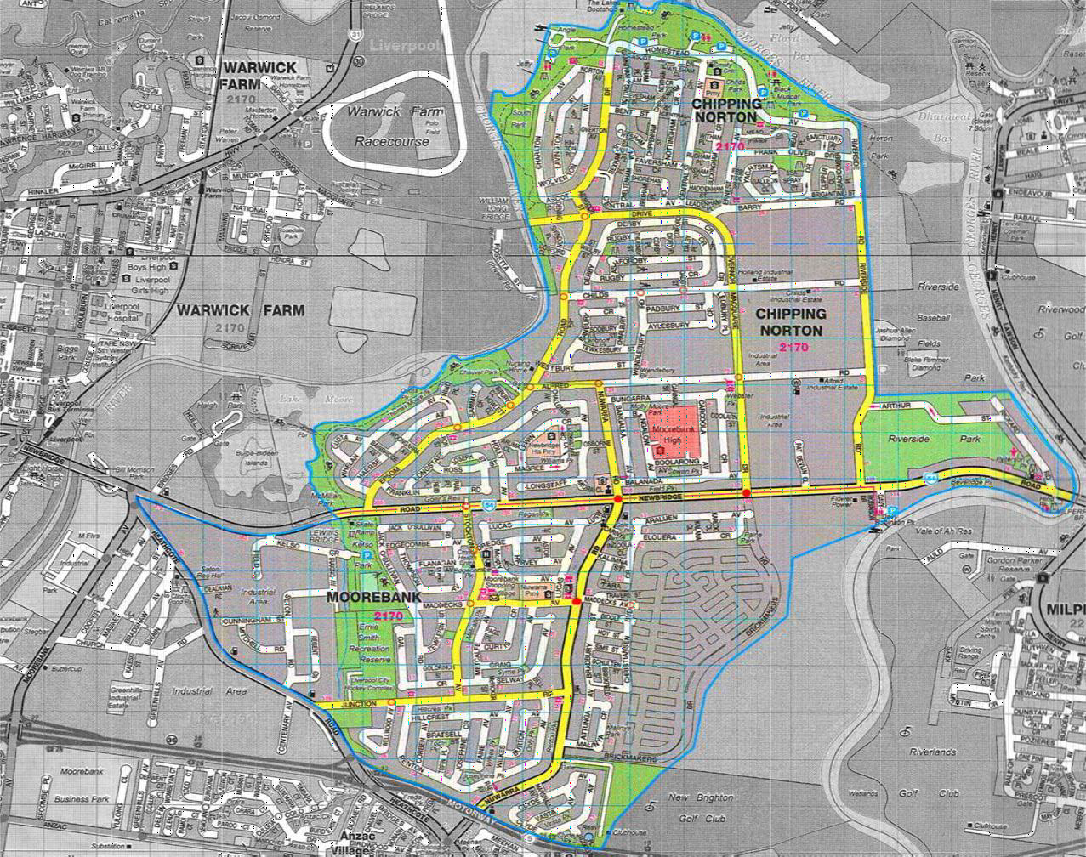

### Appendix 2: Residential address check

